Same principle as previous portfolio exercises.
First, I start with the baseline run:
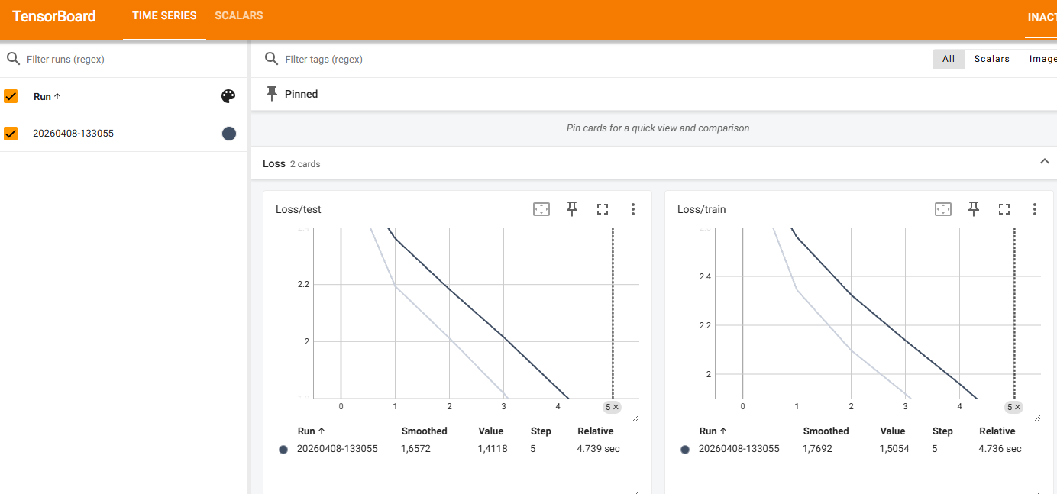
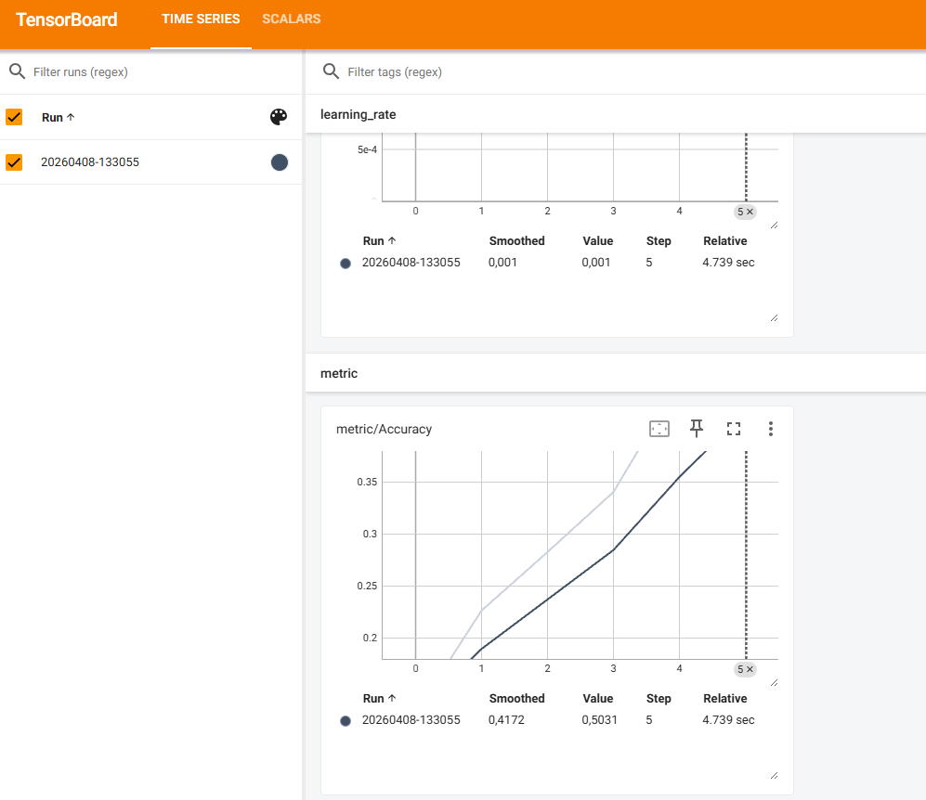
For the second iteration, I decided to tweak the parameters of the GRU model
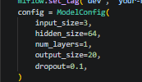 original parameters
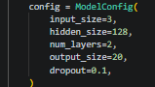adjusted parameters
This resulted in longer training, but also in….:
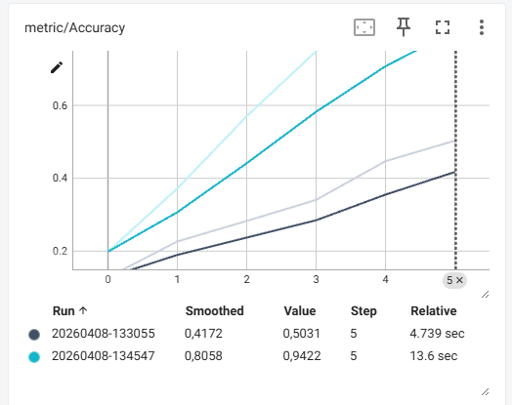
A way better accuracy score!
Next I increased hidden size even more and also dropout a bit to prevent overfitting.
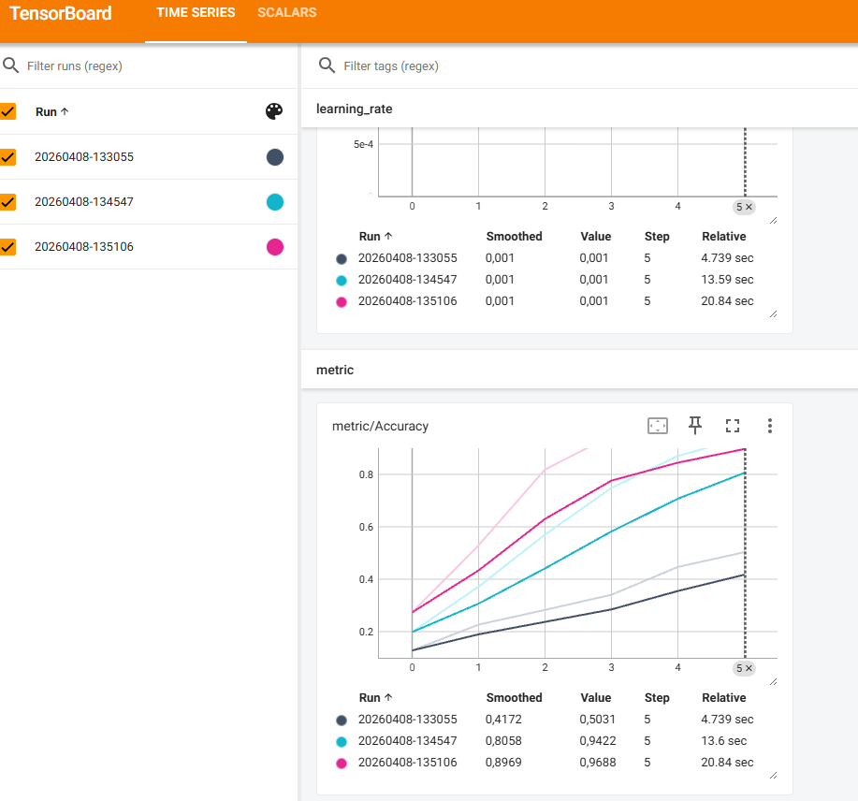
This last run achieved an accuracy well above the mentioned goal in the script, so it seems like mission successful.

